# ON-LINE SUPPLEMENT

# Positive Expiratory Pressure: A Potential Therapy to Mitigate Acute Bronchoconstriction in the Asthma of Obesity

Swati A. Bhatawadekar, Anne E. Dixon, Ubong Peters, Nirav Daphtary,

Kevin Hodgdon, David A. Kaminsky, and Jason H.T. Bates

Pulmonary Disease and Critical Care Medicine, University of Vermont College of Medicine, Burlington, VT 05405, USA

# Methods

Respiratory Oscillometry

Respiratory system impedance (Zrs) was measured using a modified flexiVent ventilator (Scireq, Montreal, Canada). The piston-cylinder assembly of the flexiVent that is employed for small animal experiments was replaced by a custom designed assembly comprised of a 100 ml cylinder connected to a heated pneumotachograph (3813 series, Hans Rudolph, Kansas City, MO) for measuring mouth flow and a piezo-resistive pressure transducer (SC-24, Scireq, Montreal, Canada) for measuring airway opening pressure. Participants could breathe normally to the atmosphere by inspiring room air through a one-way valve and expiring through an adjustable spring-loaded PEP valve (Ambu, Copenhagen, Denmark). The inspiratory and expiratory pathways to atmosphere were located between the cylinder assembly and the site of pressure and flow measurement. PEPs of either 0 or 10 cmH2O were applied, as dictated by the protocol being applied (Table 1), by rotating the graduated gauge on the valve to its corresponding setting. The partial barrier created by the PEP valve had a flow resistance of 5-10 cmH2O.L-1, ensuring that most of the flow oscillations entered the lungs (rather than exiting through the expiratory pathway) while still allowing the participants to breathe spontaneously. Methacholine aerosol carried on an airflow of 100 ml.s-1 from an ultrasonic nebulizer (Hudson RCI, Teleflex, Westmeath, Ireland) directed into the breathing circuit at a point distal to the bacterial filter. A schematic of the oscillometry setup is shown in Fig. S1.

Analysis of Methacholine Challenge Oscillometry Data

During the oscillometry measurements, oscillating flow of 8 sec duration was applied four times per min (every 15 sec) to the lungs. The flow signal () was comprised of 6 mutually prime frequency components at 5, 7, 11, 13, 17, and 19 Hz with roughly equal amplitude at each frequency. This signal consisted of a 1-s period repeated 8 times.Airway opening pressure () and were anti-alias filtered at 30 Hz (6-pole Bessel low-pass filter) and sampled continuously at 256 Hz throughout the 16 s oscillations and retained for analysis.

The and signals were analyzed using custom-designed software. The signals were first low-pass filtered to isolate their spontaneous breathing waveforms ( and , respectively) from the imposed oscillations ( and , respectively). This was done by convolving the signals with a series of finite windows of unity height, the window lengths equaling the periods of the various frequencies of the individual imposed oscillations. The oscillatory components were then determined as and .

The pressure and flow signals were filtered to remove their components due to the subject’s breathing, and divided into 1 s windows that overlapped by 50%. The mean cross and auto power spectral densities were calculated as

(S-1)

and

where n=15, the functions of in Equations (1) and (2) are the fast Fourier transforms of the corresponding time domain signals within each of the overlapping windows, and * denotes the complex conjugate. Impedance for the entire 8-s measurement period was calculated as

(S-3)

(S-2)

for Hz, where and are the real and imaginary parts, respectively, of impedance (also referred to as resistance and reactance, respectively).

Zrs(f) calculated as above was fit with a two-compartment series model of the lung having 5 parameters – central compartment resistance, elastance and inertance (, and respectively) and peripheral compartment resistance and elastance ( and respectively). The parameters of the central compartment account for the mechanical properties of the central structures, at least some of which are likely proximal to the trachea, while the parameters of the peripheral compartment account for the mechanical properties of the distal lung structures.

The impedance of this two-compartment model () is given by the following system of coupled equations:

(S-6)

(S-5)

(S-4)

was fit to a grid search method (1). This provided time-courses of model parameters over the 8 min measurement period. This model gave comparable qualities of fit to the data from each of four study visits S1 through S4 (Table 1), as shown by the similar levels of root mean squared residual (RMSR) between data and model fit shown in Fig. S2.

The quality of the impedance measurements was assured by discarding Zrs values having coherence < 0.85. We calculated the mean and standard deviation (SD) for each model parameter at each time point for each of the four study visits. In each case, we then discarded values outside ± 2 SD from the mean, and recalculated a revised mean and standard error (SE). This was necessary because the methacholine challenge tended to make the participants cough, and when this happened during Zrs measurement, it often rendered the measurement uninterpretable.

Analysis of Relaxed Expiration Oscillometry Data

At each of the 4 study visits, we also had the subjects perform a relaxed expiration from total lung capacity (TLC) to functional residual capacity (FRC) by exhaling passively for 16 s through a high-resistance pathway while Zrs was measured continuously. This enabled us to track how lung function depended on lung volume as we have previously reported (1). This procedure was performed in triplicate before administering a 4.5 min methacholine challenge, and the maneuver with the greatest change in lung volume during expiration was retained for analysis.

The flow oscillations applied during relaxed expirations were comprised of 5 sinusoidal components having frequencies at 4, 6, 10, 14 and 22 Hz (these frequencies are non-integer multiples of each other in order to minimize harmonic cross-talk) with roughly equal amplitudes at each frequency. This signal has a fundamental frequency of 2 Hz and thus a period of 0.5 s, so it was comprised of 32 repeats of the same 0.5 s signal. Respiratory system impedance could thus be followed throughout expiration with a high temporal resolution of 0.5 s. Because of the high-resistance pathway at the expiratory port the lungs emptied much more slowly than normal, but reached FRC by the end of the 16 s oscillatory period.

and were analyzed in 0.5 s windows that overlapped by 50% and at each of the 5 frequencies was determined by dividing the averaged cross- and auto-power spectra in the Fourier domain as described above.

The 5 values of and were simultaneously fit with a single-compartment model of the respiratory system, which has impedance () given by

(S-8)

(S-7)

is respiratory system resistance which, over the frequency range 4-22 Hz, approximates the overall flow resistance of the airway tree (2) because the resistance of the lung tissues over this range is negligible and the contribution from the chest wall tissues is small and approximately constant (3). and are respiratory inertance and elastance, respectively. Values for , and were determined by fitting Eq. 2 to by multiple linear regression within each window, yielding time courses for all three parameters over the 16 s measurement period, that is , and , respectively. At the same time, the change in lung volume relative to total lung capacity (TLC) was computed as

Finally, was normalized to begin at 1.0 and end at 0 over the 16 s measurement period, and , and were resampled to each have 1000 points equally spaced in volume, so that the volume dependencies of , and for all participants within each group could be averaged.

For the impedance measurements made continually during 16 s relaxed expirations from TLC to FRC, we fit the single-compartment model of the respiratory system. This provided a value of respiratory system elastance, Ers, every 0.25 s that we related to lung volume on a normalized scale between 1 (TLC) and 0 (FRC), (Fig. S3) as described in our previous study (1).

Statistical Analyses

For the initial 4.5 min period, the data from the three PEP 0 visits (S1, S3, S4) were averaged, and compared with the PEP 10 visit data (S4), allowing us to determine the effects of PEP on the development of bronchoconstriction during methacholine challenge. For the subsequent 3.5 min period, the average data from the two PEP 0 visits (S1, S3) were compared with the averaged data from the two PEP 10 visits (S2, S4), which allowed us to determine the effects of PEP on established bronchoconstriction. To compare parameters between any two visits, the differences in the two visit means (Δ) and the SD of the difference (σ) were evaluated at each time point. The mean and SD of these Δ and σ were then calculated under the assumption that the two quantities are point estimates of the same random variable so that we could compare them with zero by paired t-test with Bonferroni correction applied for the comparison of multiple parameters. Statistical significance was accepted at p < 0.05, and analyses were conducted using SPSS (v26.0, IBM Corp. in Armonk, NY).

# Results

Data inclusion

The numbers of subjects at each visit are given in Table 1 and shown in Fig. S4. A total of 22 participants were recruited for the study. The first 4 of these are not included in the analysis because we initially nebulized the PC20 concentration of methacholine for only 2 min. However, we found through on-going data analysis that this produced too small a response to be measurable above the noise, no doubt because the methacholine aerosol reached the lungs less efficiently via our oscillometry system compared to the conventional nebulizer we had used in the pulmonary function lab to determine PC20. This finding resulted in us increasing the duration of nebulization to 4.5 min, which produced a measurable response in Zrs. Of the remaining 18 participants, 11 completed all four PEP protocol visits S1 through S4 (Table 3). Two participants failed to return for one of these visits, and one participant returned for only one of the visits. Four participants mistakenly had one of the PEP protocols repeated, so the data from the repeated protocol were discarded, leaving data for only 3 of the visits in each case.

# References

1. **Bates JHT, Peters U, Daphtary N, MacLean ES, Hodgdon K, Kaminsky DA, Bhatawadekar S, and Dixon AE**. Altered Airway Mechanics in the Context of Obesity and Asthma. *J Appl Physiol (1985)* 2020.

2. **Bates JHT**. The role of airway shunt elastance on the compartmentalization of respiratory system impedance. *J Eng Sci Med Diagnost Ther* 2: 011001-011001, 2019.

3. **Bates JH, Irvin CG, Farre R, and Hantos Z**. Oscillation mechanics of the respiratory system. *Compr Physiol* 1: 1233-1272, 2011.

**Figure S1:** Experimental setup used to measure impedance during and after administration of methacholine aerosol while controlling end-expiratory pressure.

**Figure S2**: RMSR (mean ± SD) between and for each time point at each of the study visits.

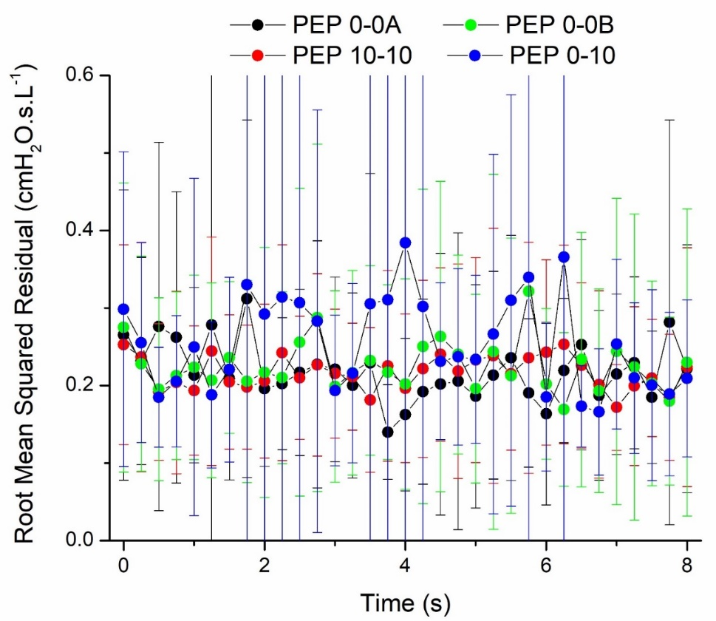

**Figure S3:** Elastance of the respiratory system (Ers) versus lung volume normalized to the range TLC (corresponding to a value of 1) to FRC (corresponding to a value of 0) for each of the four study visits indicated in Table 1.

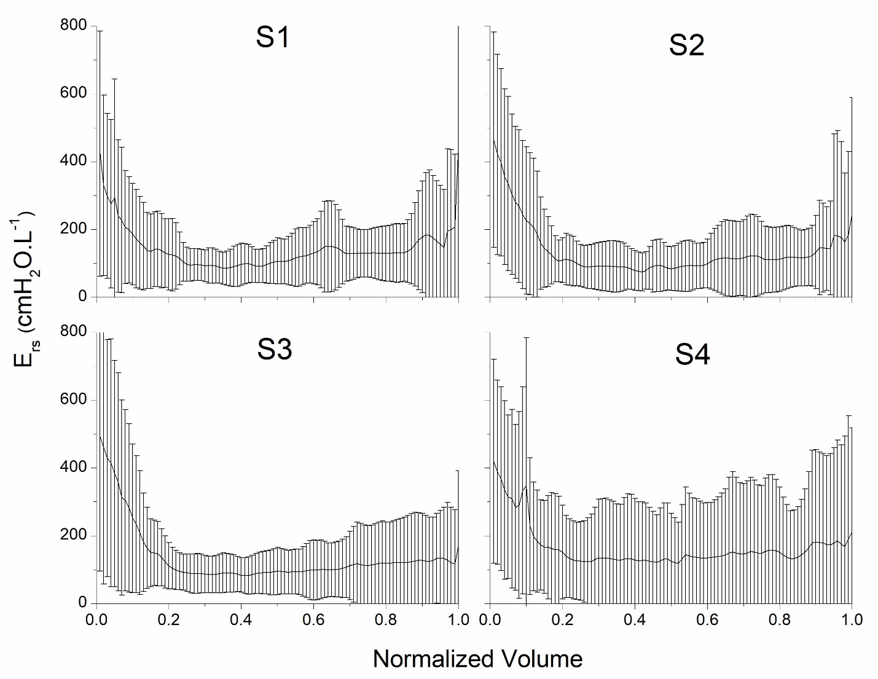

**Figure S4: Consort diagram depicting data included in the analysis.**

Total number of participants recruited

N=22

Excluded from analysis due to insufficient methacholine delivery in the first 4.5 min

N=4

Participants for revised protocol

(methacholine delivery 4 min)

N=18

Excluded from visit-wise analysis

------------------------------------------

Failed to return to 1 of the 4 visits, N=2

Failed to return to 3 of the 4 visits, N=1

Exclusion of one mistakenly repeated PEP protocol data, N=4

Included for analysis of 4 visits

------------------------------------------

Data analyzed for visit S1, N=16

Data analyzed for visit S2, N=14

Data analyzed for visit S3, N=17

Data analyzed for visit S4, N=16

Data analyzed for all visits S1 to S4, N=11

**Figure S5: Figure 2 of the main manuscript with the inclusion of the data points (mean ± SE).**

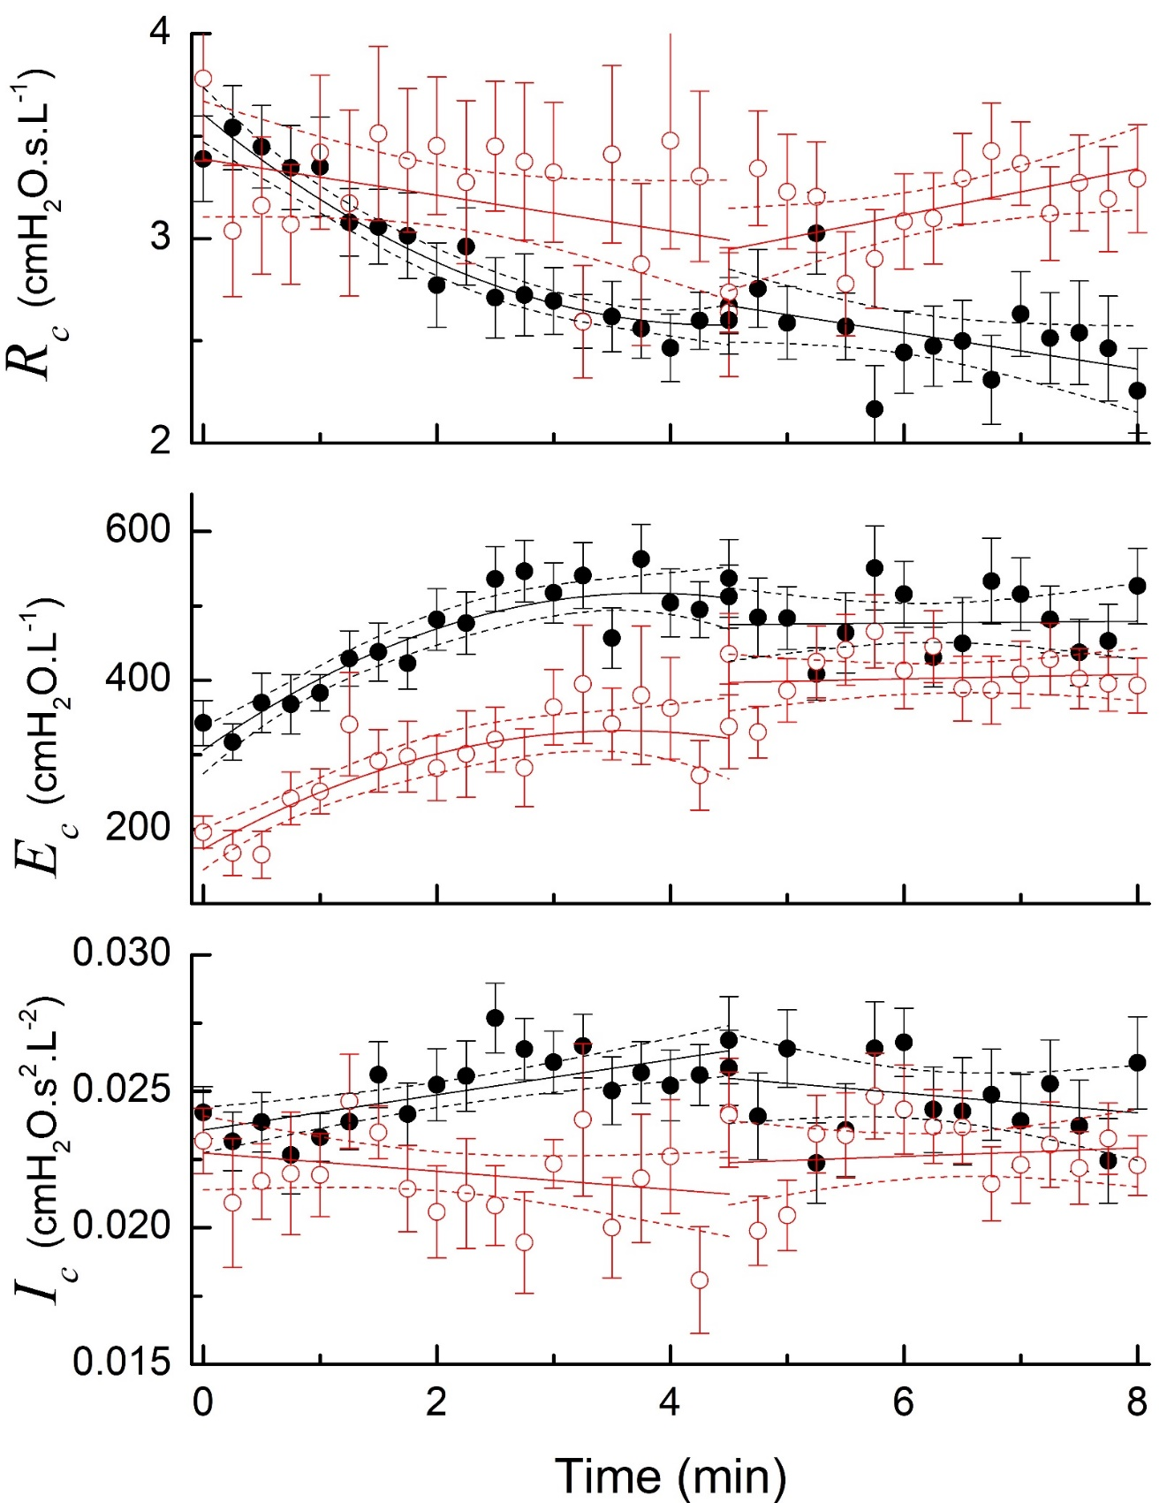

**Figure S6: Figure 3 of the main manuscript with the inclusion of the data points (mean ± SE)**

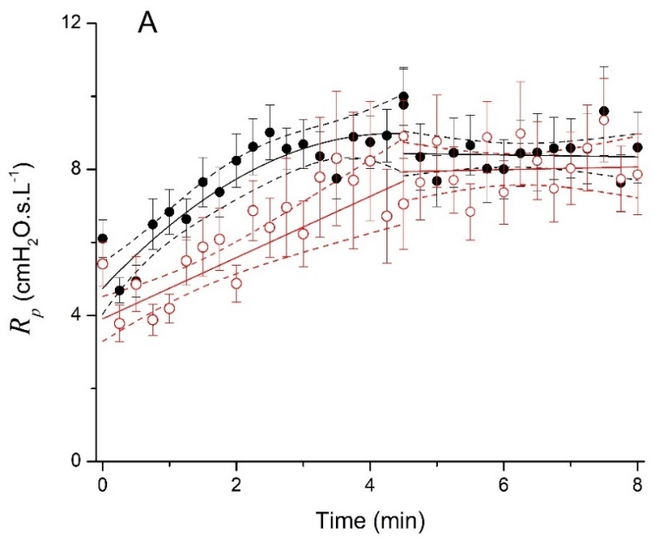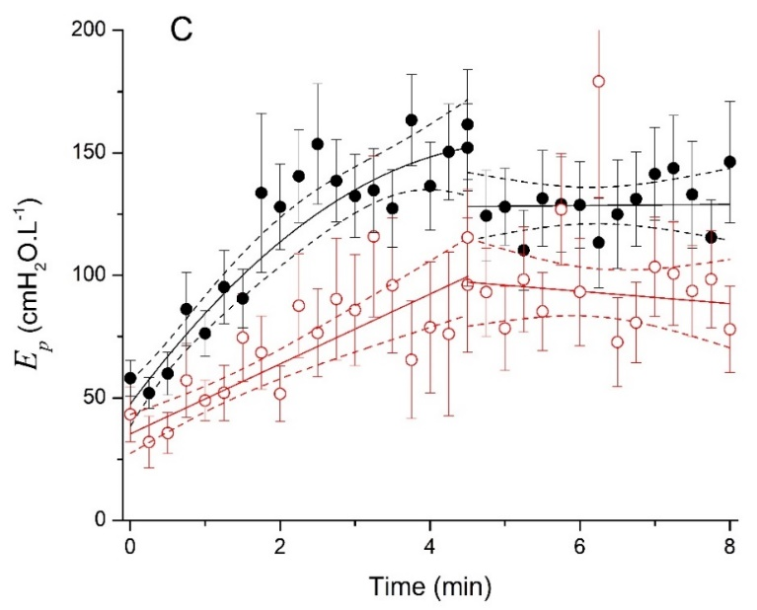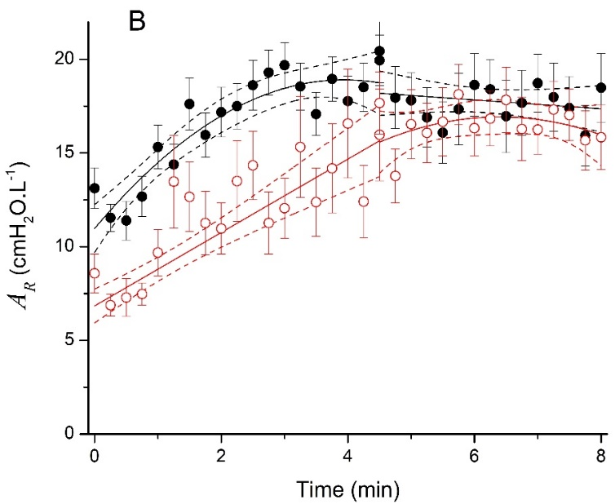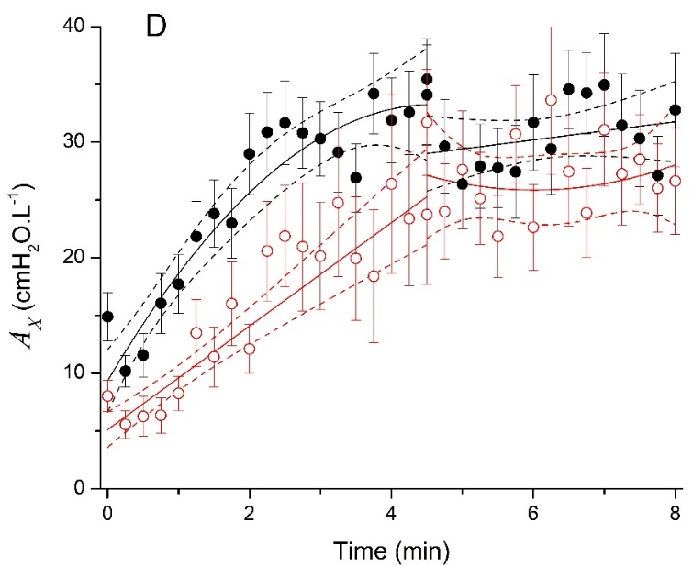

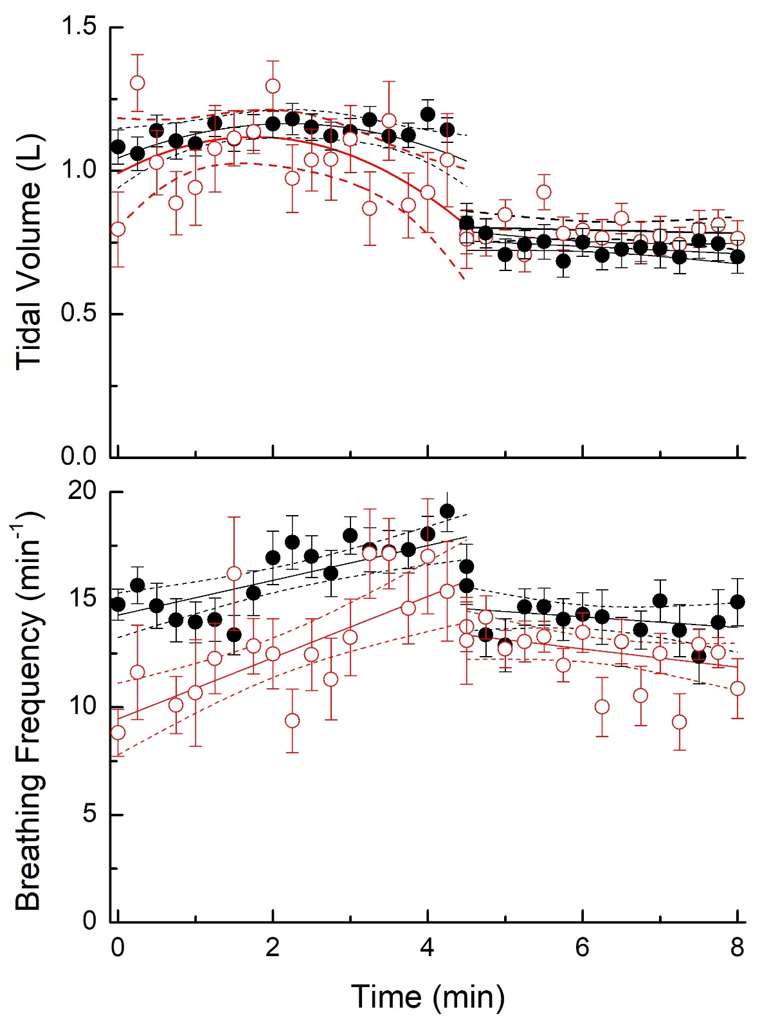**Figure S7: Figure 4 of the main manuscript with the inclusion of the data points (mean ± SE)**